Chapter 19, Problem 5.

Obtain the z parameters for the network in Fig.19.69 as functions of s.

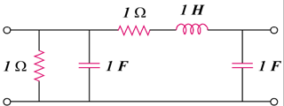

1 Ω

1 F

1 H

1 Ω

1 F

Figure 19.69
For Prob. 19.5

